LUGOU BRIDGE

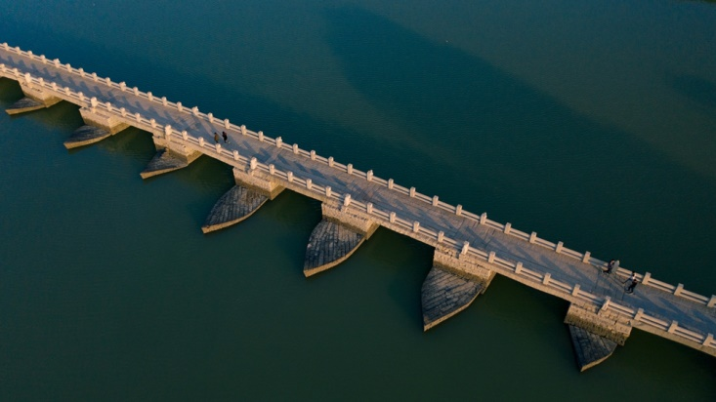

The Lugou Bridge, also known as the Marco Polo Bridge, is a famous historical bridge located in the southwest of Beijing, China. It spans the Yongding River, a tributary of the Hai River. The bridge has a rich history dating back to the Jin Dynasty (1115–1234) and has undergone several renovations and expansions over the centuries.
Originally constructed during the Jin Dynasty, the bridge was later rebuilt during the Yuan, Ming, and Qing dynasties. The current bridge primarily reflects its Ming Dynasty (1368–1644) construction.
Lugou Bridge is renowned for its architectural beauty and historical significance. It is a stone bridge with 266 meters in length and 9.3 meters in width, featuring 11 arches. Each arch is adorned with ornate stone carvings depicting scenes from Chinese mythology, historical events, and nature, making it a masterpiece of ancient Chinese bridge architecture.
The bridge gained international attention during the Second Sino-Japanese War (1937–1945). The Marco Polo Bridge Incident, which occurred near the bridge on July 7, 1937, marked the beginning of full-scale warfare between China and Japan. Today, the bridge serves as a symbol of resilience and resistance against foreign aggression.
Lugou Bridge is not only a historical landmark but also a popular tourist destination, attracting visitors interested in Chinese history, culture, and architecture. Its picturesque setting amidst lush greenery and the flowing Yongding River adds to its charm, making it a must-visit attraction in Beijing.

